**TEST SUITES**

**DIFFERENCE BETWEEN TEST TEMPLATE AND TEST SUITES**

|  |  |
| --- | --- |
| **TEST TEMPLATE** | **TEST SUITE** |
|  |  |
| An ATF test template is a reusable set of test steps that are commonly used together. Test Templates can include any combination of test steps. A template's test steps may require additional configuration once added to a test. | Test suites are hierarchical, logical groupings of related tests and/or other test suites to run as a single job. |

**Accessing Test Suites**

**Filter Navigator 🡪 Search Suites**

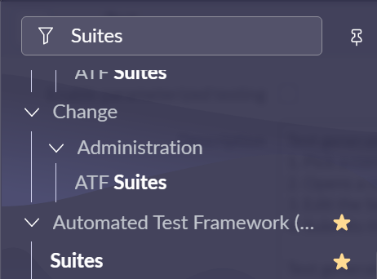

**Creating a New Test Suites**

**Name: Suite Test**

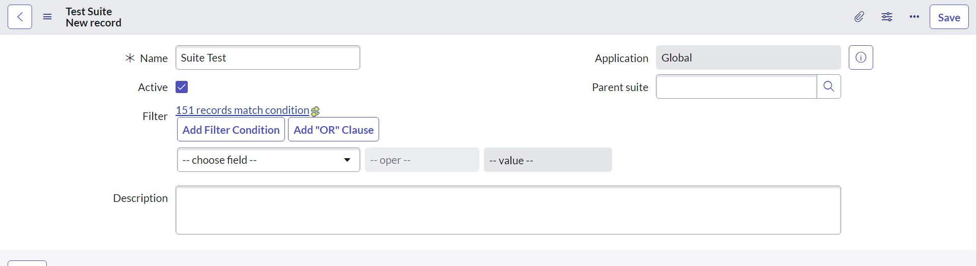

**To Import Tests with common Name, Use the Filter Option**

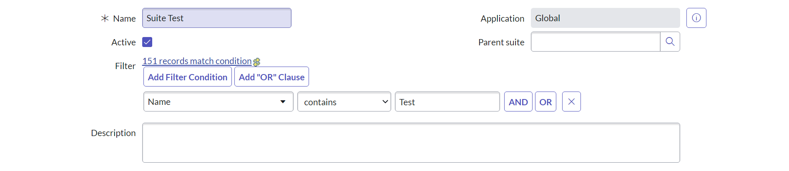

**We See 19 Tests has been imported**

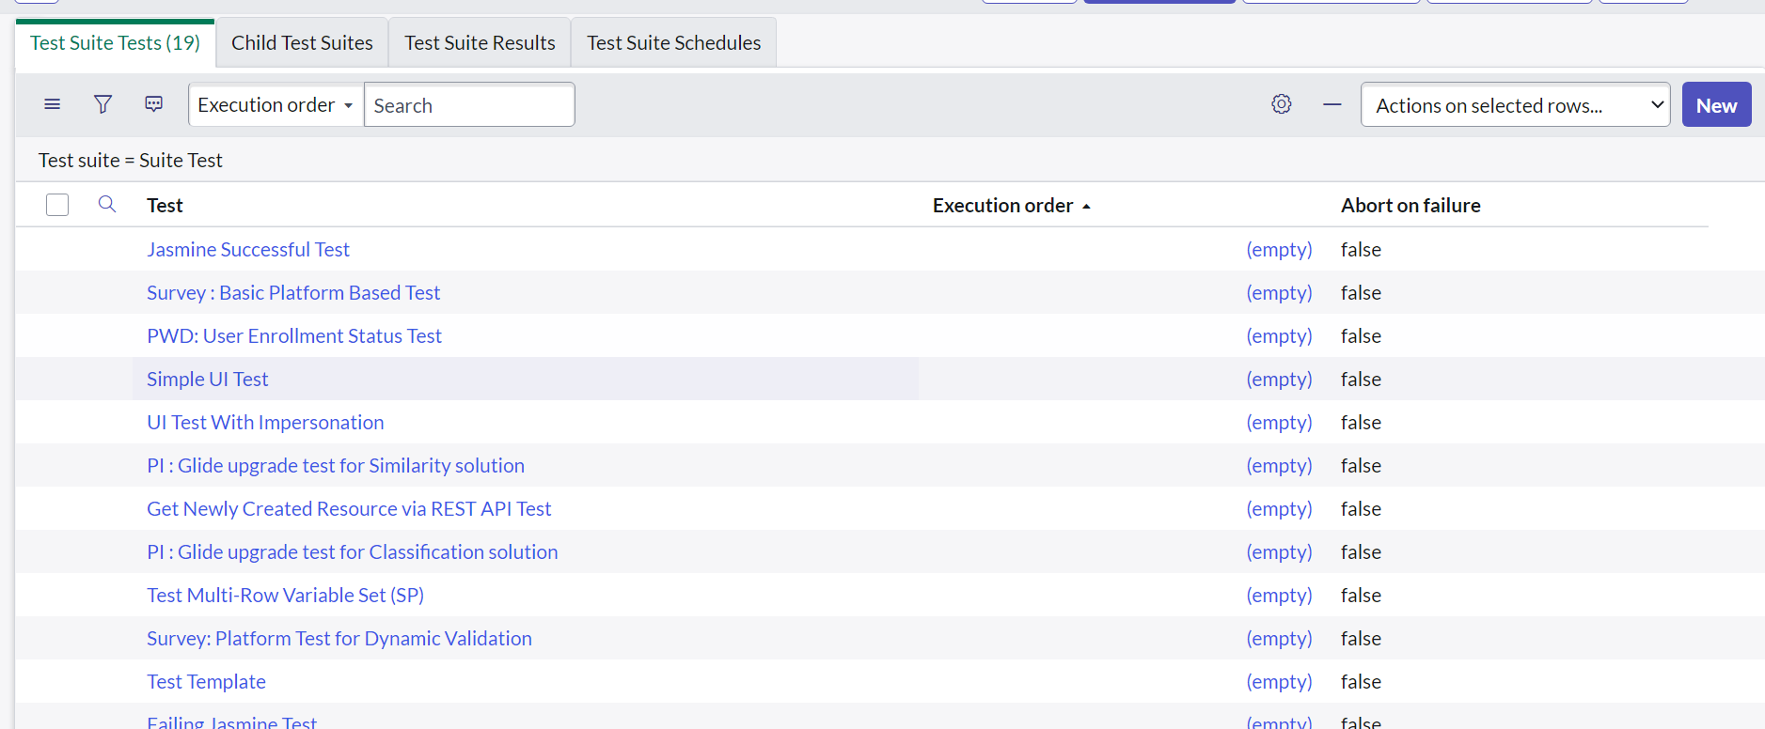

**We can also Create Child Test Suites**

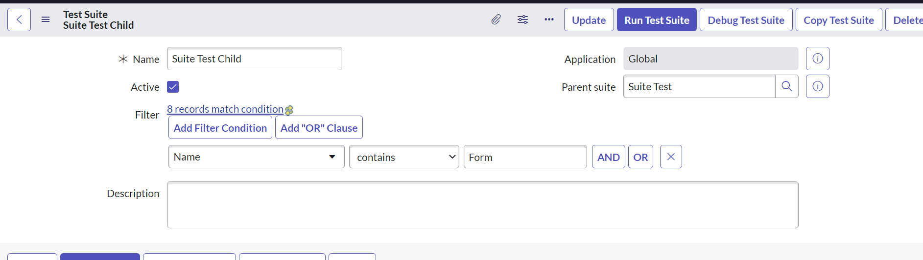

**We have added the Filter Condition**

**We see 6 Tests have been Imported**

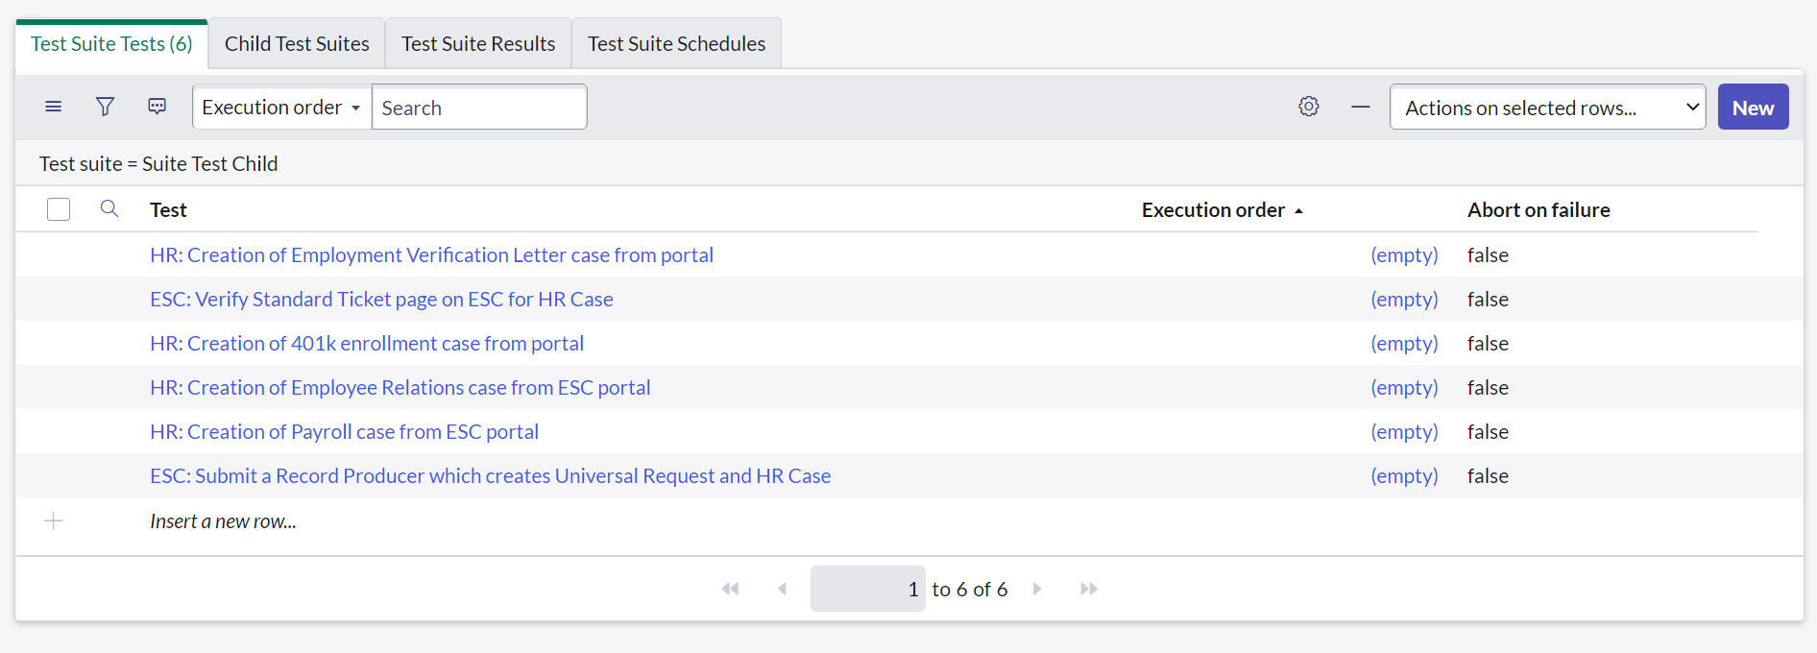

**RUN TEST**